Linking boundwith records in Alma – serials records

Separately-cataloged items that are bound together are linked using a host record.

Boundwith linking - summary
Each title in the volume should have its own bibliographic record, with a placeholder holdings (in that library’s “bound” location) and item record attached. A template is used to create a host record, with the individual titles and MMS ID numbers listed in 774 fields. The holdings/item pair attached to this record contains the call number, location and barcode associated with the bound volume.
NOTE: Bound withs for Special Collections will not look like the ones created according to these procedures, due to their appearance in AEON. Instead of having a Bound location, Special Collections holdings will look like this:
‡b SCL ‡c Hargr_Rare ‡x Boundwith
This is fine and you can leave these as-is!

Preparing the individual titles.

These procedures assume you have already imported the bibliographic records for each title. In the following example, a bound volume contains three separate titles.
1. Retrieve the record for the first title in the volume. Open up a text editor program and copy the MMS ID into it. Click on Edit Record to open the MD Editor.
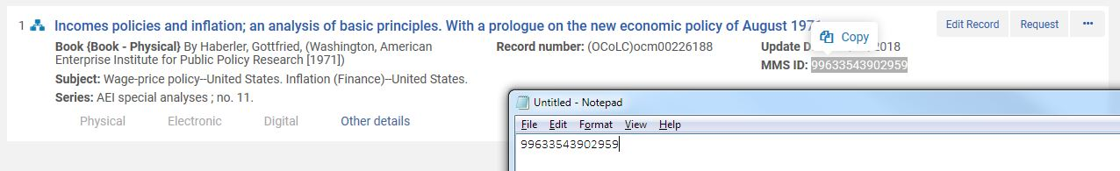
2. Copy the full 245 $a title to the text editor below the MMS ID. You will be pasting these into the host record later. Then click on Add Holdings ([CTRL]-[ALT]-H).
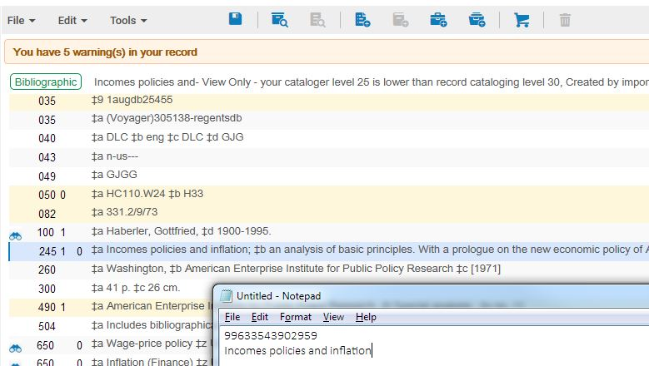

Serials may or may not have issues that are not involved in the Bound With. When there are other issues not bound with any other title, that holdings records will be attached to the bib record for the title and display in Alma. Other serials may have all of their issues involved in the Bound With, in which case the bib record would have no “real” holdings record of its own. Regardless of whether the serial will have any other holdings record attached, please go ahead and add a placeholder record for the “Bound” location. This is just an extra precaution to make sure that the bib record will still show up with our holdings attached in the Network Zone, even if other copies or issues are withdrawn.
3. Click on the 852 and open the Form Editor ([CTRL]-F). Select the library where the volume is housed, then find the “Bound” location for that library (the location code will always begin with “Bound”).
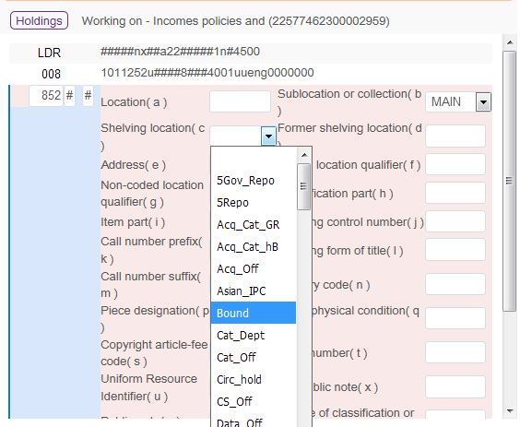
4. Make sure you set the 852 first indicator to 6, so that Alma does not automatically fill in the call number from the bib record.
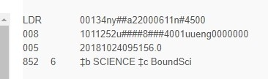
5. Suppress the record via Tools/Set Management Tags/Suppress from Discovery. Save the record.
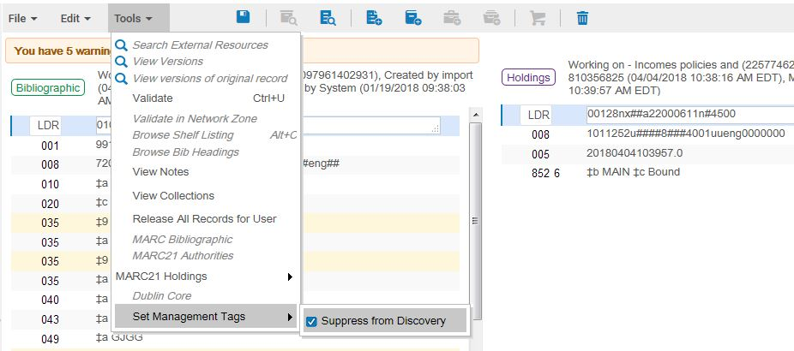
6. Add an item record ([ALT]-I).

7. This is just a placeholder record. It doesn’t need a barcode, or any other information, so Save ([Enter]) the unedited item record.
8. Repeat steps 1-7 for each title in the volume.

Creating the host record

1. First, make sure you are set to save newly-created records to the IZ (i.e., Local). Open the MD Editor. Under the File menu, click Options.
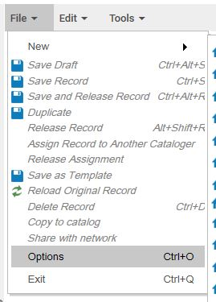
2. Under Placement of new bibliographic records, click on the Local radio button. Then click Save.
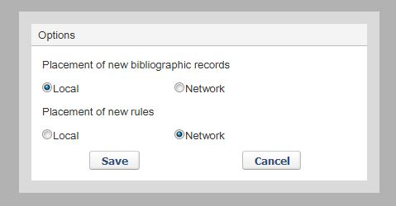

3. To the left of the MD Editor, click on Templates, then MARC21 Bibliographic, then Shared. Find the template called Boundwith host record, and click on New.
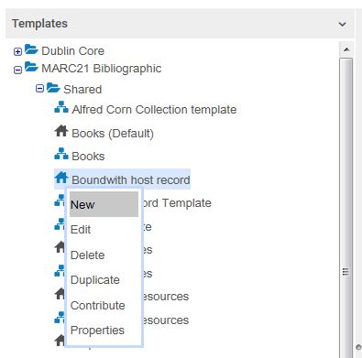
4. In the 245 $a field, enter a title for the whole volume. Consider text on the spine as being the most valuable. If there is no spine text, use the cover text. If there's no cover text, use the first title in the volume, followed by "and others." Since this field is the only identifying information that shows up in a patron's account, the goal is to create a title that will be recognizable to them. It is also the only information Access Services staff are given in their list of Hold Shelf items. In this example, there is plenty of spine information available for the 245.
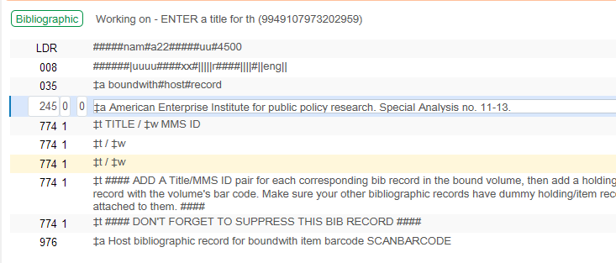

5. Copy/paste each title and MMS ID pair from your text editor into a separate 774 field, with a / between title and $w. The $w MMS ID is crucial, as this is what links the host record to the constituent bib records.
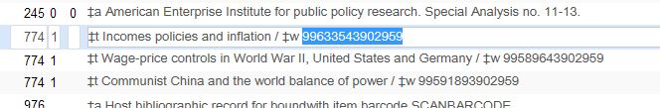
6. In the 976 field, scan the barcode of the volume to replace the text “SCANBARCODE”.
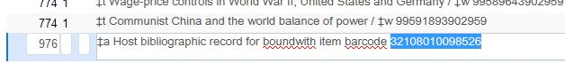
7. Suppress the record via Tools/Set Management Tags/Suppress from Discovery. Save the record.
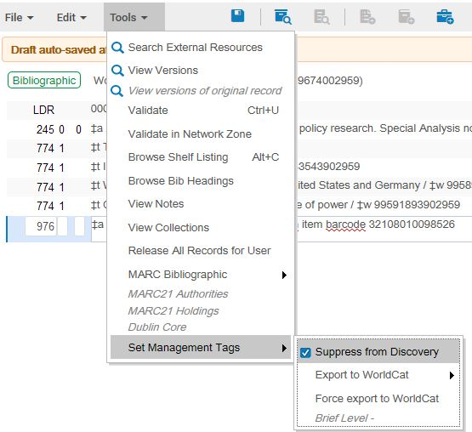
8. Add a holdings record ([CRTL]-[ALT]-H).

For bound with serials holdings where not all issues of the serial are involved in the Bound With, there may be some overlap between the bound with holdings and the holdings record attached to the “real” bib record. This is all right.
For example:
Holdings record attached to serial bib record:
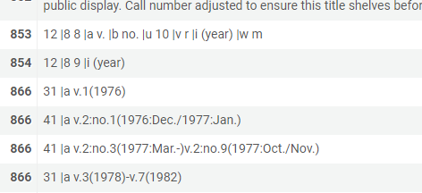
Holdings record attached to bound with bib record:
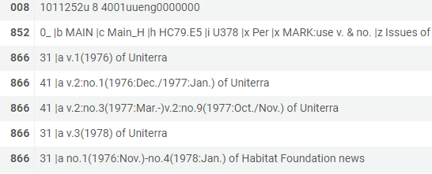
V. 1-3 of Uniterra are involved with the Bound With, and show up on both holdings. V. 4-7 are not bound with any other title, and are listed only on the holdings record attached to the “real” bib record for Uniterra, not on the Bound With holdings.
9. Enter the actual call number and location information in the 852. This is the information that will display in Primo when any of the constituent titles are searched.
For a bound with serials holding, you will need to include not only the usual enumeration and chronology information, but also information about which title the enumeration/chronology refers to. Use the 245 $a here. 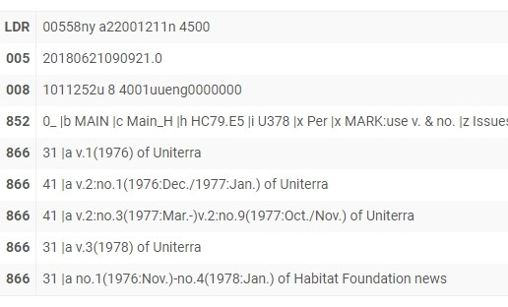
Very occasionally, you may encounter a situation where the 245s are identical (for instance, a conference may change its name, and the 245 for both preceding and succeeding records may be Proceedings). For identical 245s, use the format [110 $a]. [245] to distinguish the titles from each other in the MFHD, or use the 130 if there is no 110.
If you encounter a complicated situation that you think would benefit from further explanation in a $z note, please add a $z note or consult with the Serials Section Head.
10. Add an item record ([ALT]-I).

11. Fill in the fields for material type and Item policy, then scan in the barcode for the volume.
For Bound With item serial item records, the enumeration recorded here should reflect what will go on the spine of the physical piece.

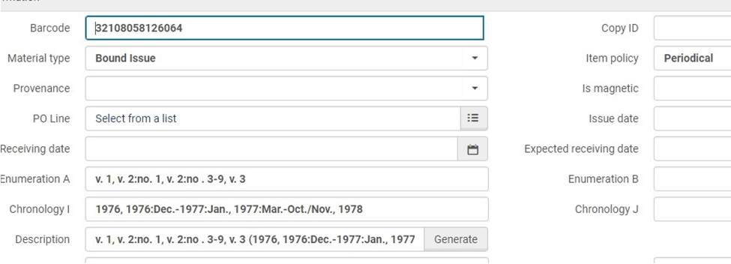

For microfilm with multiple titles filmed on one reel, there is often much more information on the box than there would be on the spine of a book. For these item records, it may quickly become impossible to format a coherent item description that reflects the enumeration on the spine.
For these item records, place all of the information, including which title the enumeration applies to, in Enumeration A. Leave the Chronology field blank. (For titles that use chronology only, enter all the information in Chronology I and leave the Enumeration field blank.) The relevant dates will still appear in the holdings record, which will display in GIL-Find.
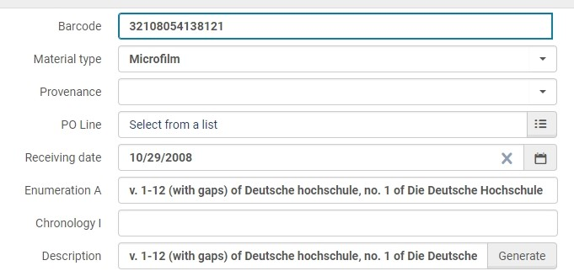

If you are unsure about how to best formulate the enumeration/chronology statement for one of these microfilm reels, please consult the Serials Section Head.

For microfilms processed as Bound Withs, also please check the Public Notes field. To help patrons access this material until the Bound With work can be done in Alma, Kennon in Acquisitions has been adding a public note, beginning, “Also contains … ” This note should be removed once the reel has been processed as a Bound With. If you are not sure whether a note from the Public Notes field should be deleted, please ask the Serials Section Head.
Save the record.

created by Simon Hunt 4/4/18 (new UI, additional procedures)
edited for serials by Jasmine Rizer 7/25/2018
updated by Jasmine Rizer 4/3/2019

